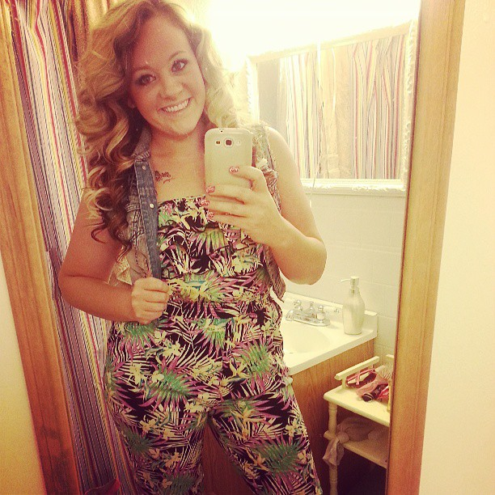
Fashion Stylist- Client Portfolio
Client Name:_ ___Kayla O’Connor_____________
Stylist Name:___________________________

Clothing Needs: Please describe the type of activities you will need clothing for in a five day period. Clothes for work, is there a dress code? Clothes for a dinner date? Clothes for a workout? Clothes for going to school activities?

I would need clothes for work. I work at East High school and have to dress professional. I don’t like to look stuffy though. I would need clothes for the winter since it is becoming cold outside. I would probably need clothes for a date night also because I am in a relationship and we like to go out to dinner and movies a lot.

Personal Style: How would you describe your personal clothing style? Trendy, Classic, Professional, Casual, Chic, Hipster, etc.
My Personal Style would be trendy, chic, vintage and professional. I like graphic tee’s, cardigans, layered look, boots, scarfs, chunky jewelry, and unique items.

Elements:
Color:
What colors do you like to wear?
I don’t have a favorite or specific color/s that I like to wear. I really like choral and teal this season though.

Which colors do you feel look best on you?
Choral, Teal, rust, and warm tones.

Line:
Do you like decorative or structural lines? Decorative are printed on the design, structural are used to create the shape of the garment? Horizontal, Vertical, Diagonal, Curved?

I like printed designs. I do NOT like horizontal lines because they make me look wide, but I do like vertical and curved lines.

Pattern:
Are there certain patterns you like or dislike? Camo, Animal Print, Floral, Polk a dots, Stripes, Geometric(Shapes), Plaid, Chevron
I LOVE LOVE LOVE animal prints especially cheetah print. I also like floral print or vintage designs.

Texture
Are there certain textures you like or dislike? Sheer, Silk, Lace, Leather, Knit, Denim

I like sheer, lace, knits, denim. I don’t like wool or anything itchy. I don’t care for silk because it is clingy and I don’t mind leather inserts, but I wouldn’t want a whole top/pants made out of leather. I like sweaters, but if they are really bulky I feel that they make me look larger than I am.

Shape
Are there certain clothing shapes that you would prefer? How do you like your clothing to fit your body? Fitted, Loose, a mix? Is there an area of your body that you like to accentuate or hide? Certain collar styles, pant fit(boot, ankle, etc.), Empire waist, high waist vs. low waist, jeggings, skinny, straight, loose fit, crew neck, v neck, etc. Short vs long skirts/skirts.

I am not a big skirt wearer. I like jeggings that are a skinny jean. I do not like jeans that are low cut because I don’t like the feeling of my butt crack hanging out. I prefer jeans that are higher waisted. I like my clothes to be a mixture of loose and fitted. I don’t want to feel uncomfortable. I would not want a belly shirt or something that is very fitted and not flattering. I would prefer loose over skin tight. I like my arms to be covered usually. I don’t like tank-tops unless I have a jacket/vest/cardigan with it because my arms are fat.

Fibers/Fabrics
Are there certain fabrics that you would prefer to stay away from? Fabrics that cling, collect static, pile, snag?
I just don’t like clingy fabrics or fabrics that have to be dry cleaned. I would prefer clothing that is easy to clean and take care of. I don’t like anything itchy either.

Accessories/Shoes
Are there certain styles of accessories you prefer? Studs vs. dangly earrings, short vs. long necklaces, bracelets, hair accessories, hats, belt, shoes(flats, sandals, boots, dressy vs. casual)?
I like dangly earrings, statement pieces, large jewelry, boots, flats, headbands. I don’t wear tennis shoes at all. I like wedges but not stilettos. I don’t wear belts to hold my pants up, but I will wear a belt around a sweater.
Stores
Which stores would you prefer to shop in? Please list at least 5 that have an online store.
*Charlote Russe
JCP
*Rue 21
TJ Maxx
Marshalls
Maurices
Kohls
*Forever 21
Younkers

*=favorites

